Name

Mathematics Stage 5 Core
Standard Deviation

Book 1 | Standard Deviation | Version: 260419  Feedback:  https://MrDingMaths.com
Contents
Syllabus Content 2
Learning Intention 3

Syllabus Content
MA5-DAT-C-01 compares and analyses datasets using summary statistics and graphical representations
Examine standard deviation as a measure of spread
- Identify standard deviation as a measure of spread
- Calculate the standard deviation of a small dataset using digital tools
- Compare small datasets using standard deviation

Standard Deviation

- Standard Deviation
Standard deviation is a number that describes how far data is spread from the mean.
It measures the ‘average’ distance of each data value from the mean using a special formula.
A larger standard deviation means more spread in the data.
A lower standard deviation means less spread and more consistency.
Small standard deviation |  | 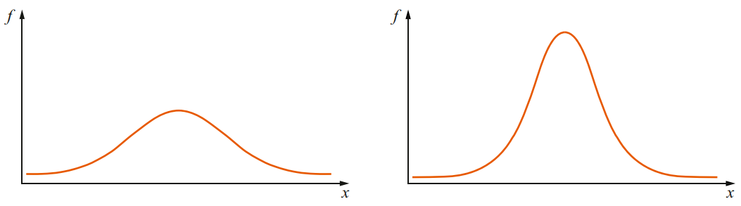  Large standard deviation
Same mean  Different standard deviation | Different mean  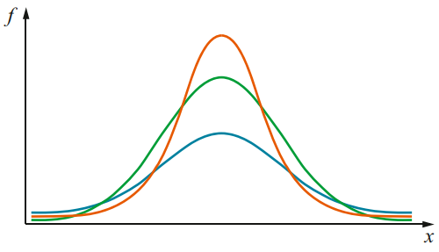  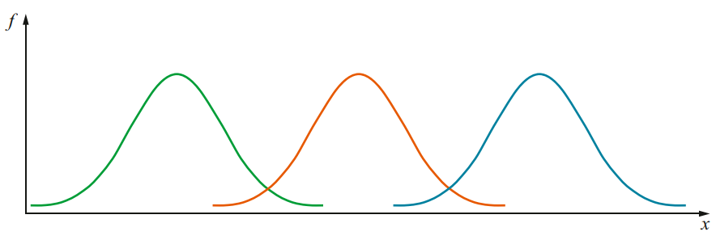  Same standard deviation

- Interpret Standard deviation
The distribution curves below are drawn with the same scale on each horizontal axis and the same scale on each vertical axis.
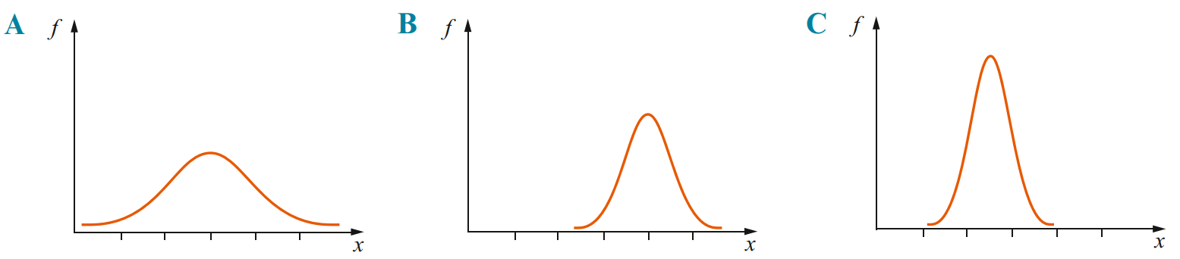

Which distribution has the:
  - Largest standard deviation?

  - Smallest standard deviation?

  - Largest mean?

  - Smallest mean?

- Two Types of Standard Deviation
$σ_{x}$ population standard deviation. ($σ$ is the Greek letter lowercase sigma)
$s_{x}$ sample standard deviation.
Always calculate population standard deviation $σ_{x}$,
unless you are specifically asked to calculate sample standard deviation.

- Standard Deviation using a Calculator
CASIO FX-82 AU
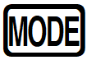
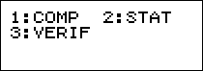
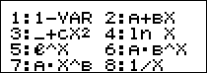
1.
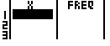

2. Enter data using arrow keys and
$x$ is the outcomes, Freq is the probabilities/relative frequencies

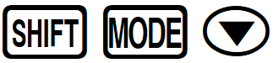
If you do not have a frequency column:
a. Enter the setup menu
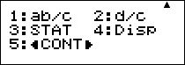
b. Scroll down and select
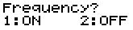
c.

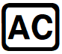
3. Press to save your data.
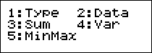
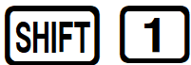
4. Enter the data menu and select
5. Calculate standard deviation.
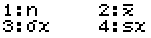
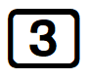
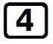
$σ_{x}$ population standard deviation.

$s_{x}$ sample standard deviation.
Then press

- Standard Deviation using a Calculator
CASIO FX-8200 AU
1. Press HOME
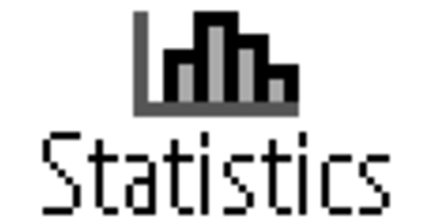
2. Select

3. Select [1-Variable]
4. Enter data using the arrow keys and
$x$ is the outcomes, Freq is the probabilities/relative frequencies
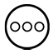
If you do not have a frequency column:

a. Press and select [Frequency] > [On]
b. Press to return to the table.

5. After entering your data, press [1-Var Results]
6. Press for the full list of variables.
$σ_{x}$ population standard deviation $s_{x}$ sample standard deviation.

- Example Calculate standard deviation
Calculate population standard deviation $σ_{x}$ of:
1, 3, 5, 7, 9
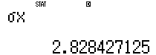

- Guided Practice
Calculate the population standard deviation, to 2 d.p., of:
- 8, 10, 12  $$σ_{x}=1.63$$ | - 18, 20, 22  $$σ_{x}=1.63$$
- 1, 4, 7, 10, 13  $$σ_{x}=4.24$$ | 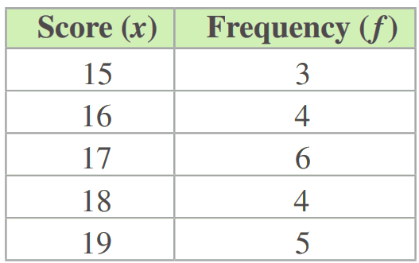  $$σ_{x}=1.34$$

- Key Ideas
- Standard deviation is a measure of how ………………… out the data is.
- Standard deviation is the ‘……………’ distance of each datapoint from the ………………

Foundation
- Calculate the population standard deviation of these datasets. Round to 2 d.p.
- 1, 1, 1, 1, 1  $σ_{x}=$  0 | - 3, 4, 6, 8, 9  $σ_{x}=$  2.28 | - 0, 0.5, 1, 1.5, 2, 2.5, 3  $σ_{x}=$  1
- 1, 1, 2, 3, 3  $σ_{x}=$  0.89 | - 2, 4, 6, 8, 10  $σ_{x}=$  2.83 | - −3, −2.5, −2, −1.5, −1, −0.5, 0  $σ_{x}=$  1
- 2, 2, 3, 4, 4  $σ_{x}=$  0.89 | - 1, 2, 3, 4, 5  $σ_{x}=$  1.41 | - −3, −2.5, −2, −1, −0.5, 0  $σ_{x}=$  1.08
- 4, 4, 6, 8, 8  $σ_{x}=$  1.79 | - 0, 1, 2, 3, 4, 5, 6  $σ_{x}=$  2 | - 0, 1000  $σ_{x}=$  500

- The results for Molly and Harry in their tests this term is listed below.
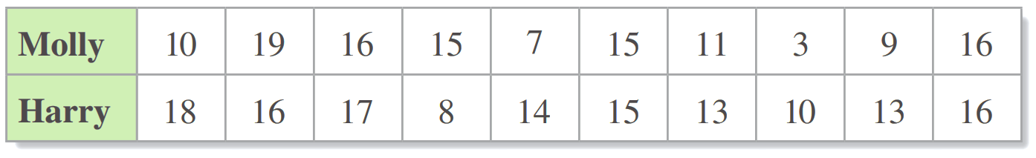

  - What is the mean and population standard deviation for Molly’s results?

Mean: 12.1, SD: 4.68
  - What is the mean and population standard deviation for Harry’s results?

Mean: 14, SD: 2.97
  - Which student had the more consistent results throughout the term? Give a reason.

Harry — lower standard deviation indicates less spread, so more consistent results.

Development
- Calculate the population standard deviation from these frequency tables to 2 d.p.
$σ_{x}=$  0.82 | $σ_{x}=$  0.82 | $σ_{x}=$  0.82
  $$x$$ | $$f$$
  1 | 1
  2 | 1
  3 | 1
  $$x$$ | $$f$$
  $$1$$ | 5
  $$2$$ | 5
  $$3$$ | 5
  $$x$$ | $$f$$
  $$2$$ | 5
  $$3$$ | 5
  $$4$$ | 5
$σ_{x}=$  0.82 | $σ_{x}=$  1.63 | $σ_{x}=$  1.19
  $$x$$ | $$f$$
  $$-2$$ | 5
  $$-3$$ | 5
  $$-4$$ | 5
  $$x$$ | $$f$$
  $$-4$$ | 5
  $$-6$$ | 5
  $$-8$$ | 5
  $$x$$ | $$f$$
  $$-4$$ | 5
  $$-6$$ | 5
  $$-8$$ | 50

- During Term 2, Rachel did 9 spelling tests. The tests were scored out of 20.
Her mean score is 15 and her standard deviation is 2.54.
  - If Rachel had scored 2 extra marks on every test,
    - What would happen to her mean?

Mean increases to 17
    - Explain why her standard deviation would be unchanged.

The spread of the distribution has not changed.
  - If Rachel had scored 15 on every test,
    - What would happen to her mean?

unchanged
    - Explain why her standard deviation would be zero.

No spread means 0 standard deviation
  - What will happen to Rachel’s standard deviation if she scores 15 on her next test?

15 is the mean. A value at the mean is 0 distance from the mean, so the standard deviation decreases
  - What will happen to Rachel’s standard deviation if she scores 0 on her next test?

0 is 15 below the mean, which is much greater than the current SD of 2.54, so adding this value increases the spread and therefore the SD

Mastery
- NAPLAN A
In a small business, the seven employees earn the following wages per week:
$300, $490, $520, $590, $660, $680, $970
  - Calculate the standard deviation for this set of data.

191
  - Each employee receives a $20 pay increase.
Explain the effect that this increase will this have on the standard deviation.

Standard deviation is unchanged as the amount of spread has not changed
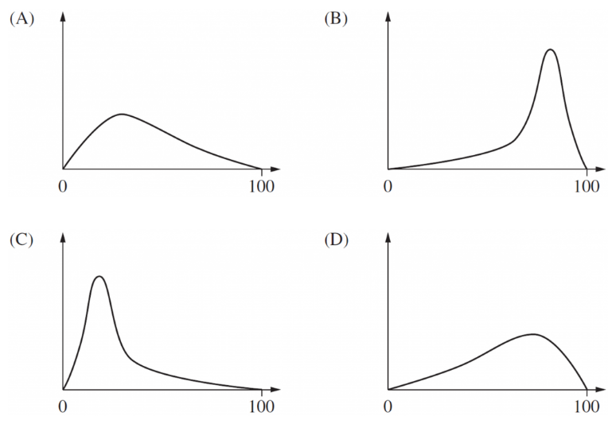
- 2006 HSC Standard 2 Band 5
Which of these graphs best represents positively skewed data with the smaller standard deviation?

Positively skewed: Tail to the right, so A or C.
Smaller SD: less spread out, so C
- HSC Standard 2 Sample Question Band 5
The dot plots show the height of students in Year 9 and Year 12 in a school.
They are drawn on the same scale.
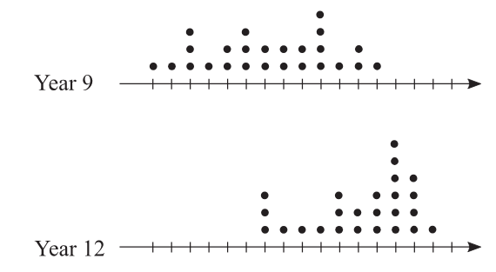

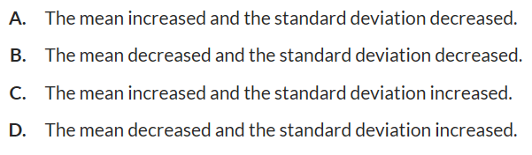
Which statement about the change in heights when comparing Y9 to Y12 is correct?

Year 12: clustered more tightly so SD decreased,
centre of data is higher, mean increased. A

